**Experiment 3 Date:** 06/03/2023

Aim:

Familiarization of Linux Commands

Course Outcome(CO2):

Perform system administration task

Procedure:

1. pwd :- print working directory

$pwd

Output:

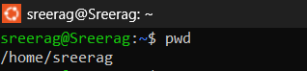

1. ls :- list directory content

$ls

Output:



1. ls -R :- list subdirectories recursively

$ls -R

Output:

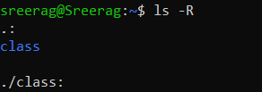

1. ls -l :- Use long listing format

$ls -l

Output:



1. ls -a :- List hidden files

$ls -a

Output:



1. ls -al :- list files and directories with detailed information such as permissions, size and owner

$ls -al

Output:

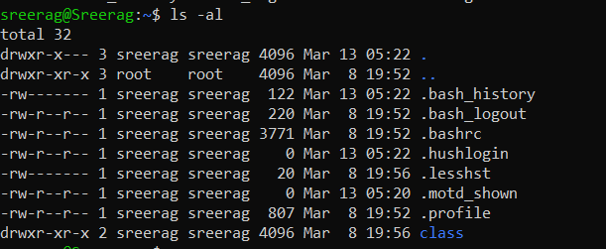

1. ls -t :- Sort by modification time, newest first

$ls -t

Output:



1. ls -r :- Reverse order while sorting

$ls -r

Output:



3. history : - Review all previously executed commands right from the shell

$history

Output:

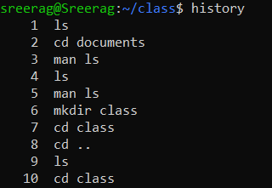

4. man :- An interface to system reference manuals

$man ls

Output:

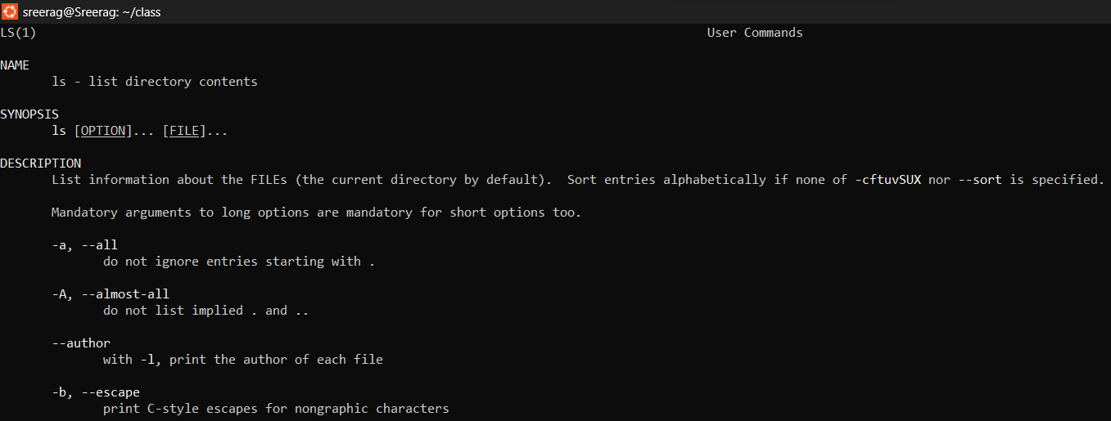

5. cd :- Change directory

$cd

Output:



6. mkdir :- Make directory

$mkdir mca

Output:

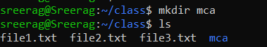

7. rmdir :- Remove empty directories

$rmdir mca

Output:

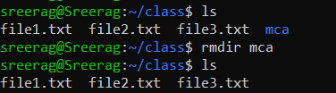

8. touch :- Create empty file

$touch

Output:

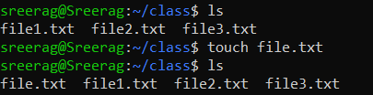

9. cat :- Concatenate files and print on the standard output

1. cat > sr.txt :- Create and write in new file

$cat > sr.txt

Output:

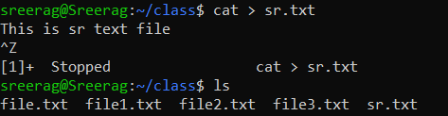

1. cat sr.txt :- Print contents of the file

$cat sr.txt

Output:



1. cat >> sr.txt :- Append information in already existing file

$cat >> sr.txt

Output:

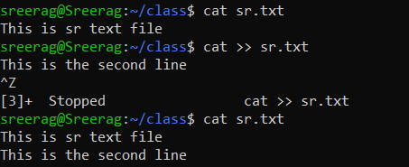

1. cat sr.txt file.txt > output.txt :- Copy contents of two files to a third new file

$cat sr.txt file.txt > output.txt

Output:

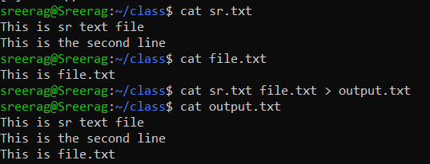

1. cat -n output.txt :- Number all output lines

$cat -n output.txt

Output:

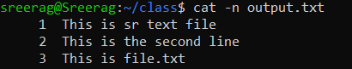

1. cat -b sr.txt :- Remove numbering for empty lines

$cat -b sr.txt

Output:

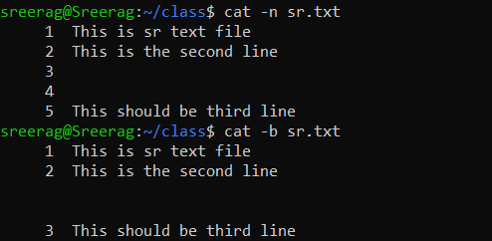

1. cat -e output.txt :- Display $ at end of each line

$cat -e output.txt

Output:

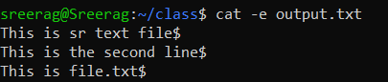

1. cat << EOF :- Displays an end marker at the end of a file.

$cat > file1.txt <<EOF

Output:

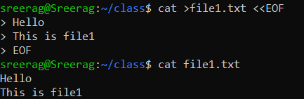

1. cat file1.txt | tr a-z A-Z > output1.txt :- To change content to uppercase

$cat file1.txt | tr a-z A-Z > output.txt

Output:

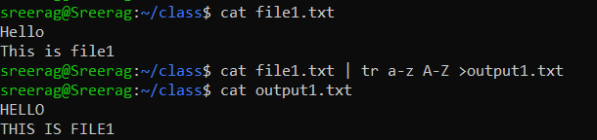

**Experiment 4: Date:** 07/03/2023

Aim:

Familiarization of Linux Commands

Course Outcome(CO2):

Perform system administration task

Procedure:

1. cut :- For cutting out the sections from each line of files and writing the result to standard output
   1. cut -b1 :- Cut by first byte position

$cut -b1 file1.txt

Output:

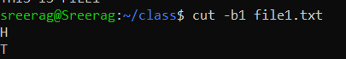

* 1. cut -c3 :- Cut by third character

$cut -c3 file1.txt

Output:

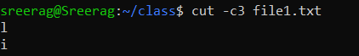

* 1. cut -d - -f1 file3.txt :- Cut by delimiter

$cut -d - -f1 file3.txt

Output:

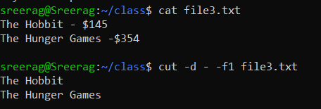

* 1. cut -c :- Select only these characters

$cut -c 1,3,5 file3.txt

Output:



1. Paste :- Merge lines of files

$paste sr.txt file1.txt :-

Output:

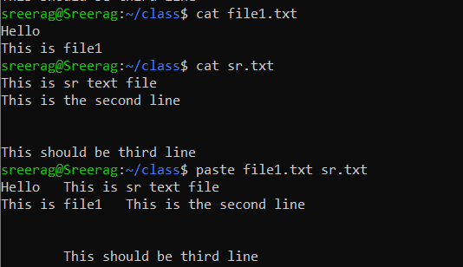

* 1. paste file1.txt output.txt> output3.txt :- Paste the merged content to new file

$paste file1.txt output.txt > output3.txt

Output:

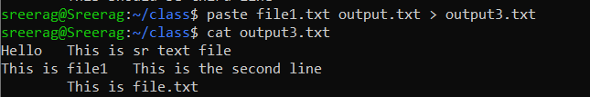

* 1. paste -d ‘%’ file3.txt output.txt :- Separate the merged parts using a symbol(%)

$paste -d ‘%’ file3.txt output.txt

Output:

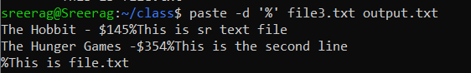

* 1. paste -s output.txt :- Display output in a single line

$paste -s output.txt

Output:



1. cp :- Copy the content
   1. cp file3.txt sr.txt : -Overwrite existing file

$cp file3.txt sr.txt

Output:

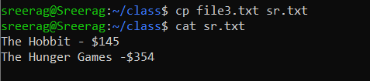

* 1. cp sr.txt output5.txt :- Copy into new file

$cp sr.txt output5.txt

Output:

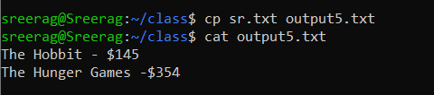

* 1. cp -r class mca :- Copy directories and subdirectories from existing directory to a new one

$cp -r class mca

Output:

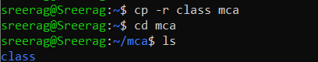

* 1. cp newfile class:- Copy file from one directory to another

$cp newfile class

Output:

